**Execute Ansible playbook using Jenkins pipeline**

This document assumes that you have prior knowledge about the Jenkins and the Ansible.

**Step 1:-**

Create an Ansible-server and make a Ansible user.

**Step 2:-**

Before login into Ansible user you have to install java and Jenkins.

Install java on your server with the following commands :

apt-get update && apt-get upgrade

apt-get install default-jdk

## **Step 3:-**

Install jenkins on your server with the following commands:

First, add the repository key to the system:

wget -q -O - https://pkg.jenkins.io/debian/jenkins.io.key | sudo apt-key add -

When the key is added, the system will return OK. Next, append the Debian package repository address to the server's **sources.list**:

sudo sh -c 'echo deb http://pkg.jenkins.io/debian-stable binary/ > /etc/apt/sources.list.d/jenkins.list'

When both of these are in place, run update so that apt will use the new repository:

sudo apt update

Finally, install Jenkins and its dependencies:

sudo apt install jenkins

Now that Jenkins and its dependencies are in place, we'll start the Jenkins server.

Let's start Jenkins using**systemctl**:

sudo systemctl start jenkins

Since **systemctl**doesn't display output, you can use its **status** command to verify that Jenkins started successfully:

sudo systemctl status jenkins

By default, Jenkins runs on port **8080**, so let's open that port using **ufw**:

sudo ufw allow 8080

Check **ufw's** status to confirm the new rules:

sudo ufw status

**Note:** If the firewall is inactive, the following commands will allow OpenSSH and enable the firewall:

sudo ufw allow OpenSSH

sudo ufw enable

To set up your installation, visit Jenkins on its default port, 8080, using your server domain name or IP address: **http://your_server_ip_address:8080**

You should see the**Unlock Jenkins**screen, which displays the location of the initial password:

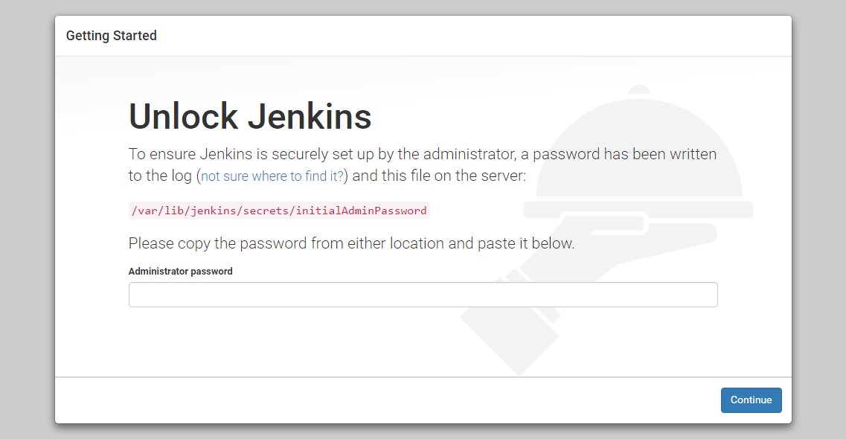

In the terminal window, use the cat command to display the password:

sudo cat /var/lib/jenkins/secrets/initialAdminPassword

**Step 4:**

Make a group and put both the user Ansible and jenkins in that group.

sudo groupadd group_name

Add user in the group and assign permission to the user with that group.

sudo usermod -a -G group_name user_name

**Steps 5:-**

And login into jenkins user and generate ssh-key by the following command

ssh-keygen

And copy that key on the Ansible-node

ssh-copy-id ansible@IP

**Note:- It is necessary to set “remote_user= ansible ” in ansible.cfg file. (/etc/ansible/ansible.cfg)**

**Step 6:-**

Copy the .yml file (ansible playbook) into the source code folder.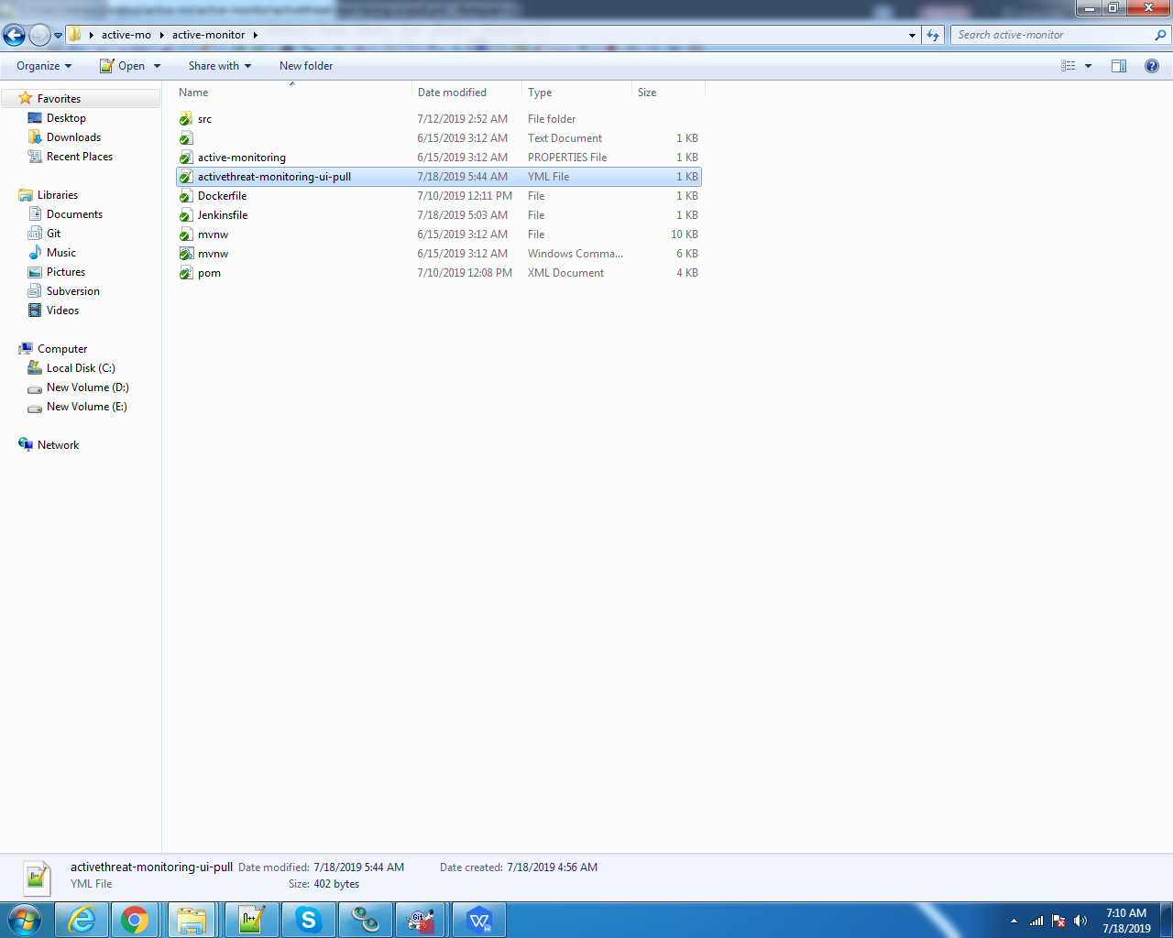

Demo of jenkins file that execute ansible playbook from the jenkins pipeline.

